How to upload data on the Darpan Portal

To upload data on the Darpan Portal(also known as CM Dashboard) we have to use the following 2 different links:-
- Darpan Count Data: Used to upload only the count of applications on the darpan portal. CM Dashboard required only a count of the applications.
Link: https://khelsathi.in/application/darpancount
- Darpan Detailed Data: This link is used to upload the applications' full details on our portal. If someone clicks on the count of applications uploaded over the Darpan portal, he must be redirected here to our portal where he can see all the application details like Name, Mobile Number, Emails, State, etc.
Link: https://khelsathi.in/application/admin/file-imports

Steps to Upload Data:

Step 1: Open the link to Darpan Count. The following page will appear
Link: https://khelsathi.in/application/darpancount
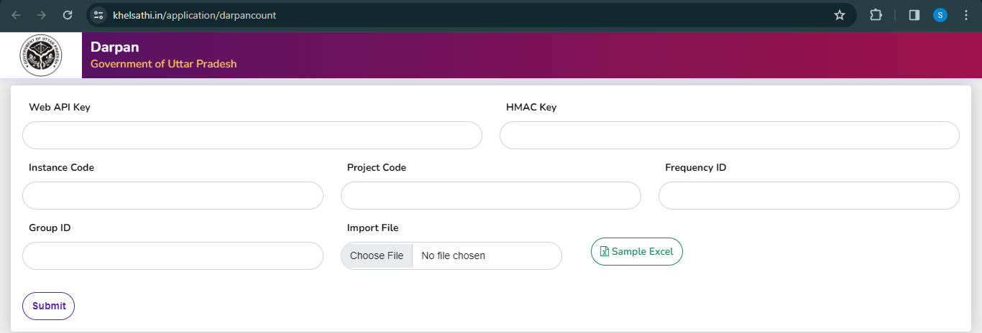

Step 2: Insert Web API, Project Code, and HMAC Key

Step 3: Insert Instance Code, Frequency ID, and Group ID:
- Instance Code for all Projects is always 2
- Frequency ID will 1
- Group ID will be 1

Step 4: In this step, you have to upload the file that contains the count data of all the districts. View the Sample file here
- You may edit this sample file and upload it as it contains the list of all districts to be uploaded. Before uploading remember the following points:
  - Cross-verify L Value data. It is a combination of 3 numbers- State Code, Division Code, and District Code.
  - Edit K Value based on application. K value is the combination of 4 numbers- Total Application Received, Total Application Accepted, Total Application Rejected, Total Application Pending
  - The sequential order of K value data as per the Scheme is listed Below:
    - Direct Recruitment: Total Applications Received, Total Pending Applications, Total Accepted Applications, Total Rejected Applications
    - Financial Assistance or Monthly Pension: Total Applications Received, Total Pending Applications, Total Accepted Applications, Total Rejected Applications
    - Laxman and Rani LaxmiBai Award: Total Applications Received, Total Pending Applications, Total Accepted Applications, Total Rejected Applications
    - Prize money for I II and III Position: Total Applications Received, Total Accepted Applications, Total Rejected Applications, Total Pending Applications
- As you can see above, the sequential order of 3 schemes is the same 1 is different. Keep this in mind

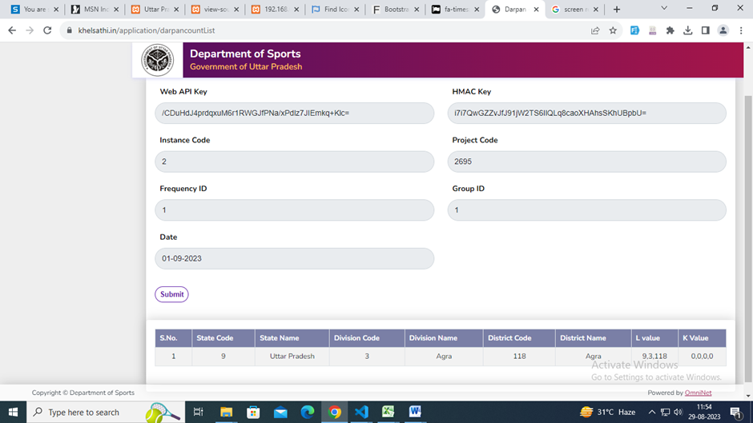
Step 5: After filling in all the details click on Submit button. The following page will appear:

Note: Cross Verify all the details from the list shown

Step 6: After cross-verifying all the details select the relevant date. Date selection is very crucial. The date selected should be the last day of the previous month as Darpan data is uploaded on the first day of every month.

Step 7: After date selection click on the Submit button which will be your final submission of the data.

Step 8: After submission of this data one has to verify the uploaded data through CM Dasboard’s Admin Login Link. The nodal officer of the department is the admin who will verify the data.
Link: https://up.cmdashboard.nic.in/AdminLogin.aspx
Note: In the Sports project, the Director of Sports is the Nodal Officer

Step 9: Post login you have to look for Pending for Verification Tab in the left side menu. When you click on this menu you will be able to see all the data you have uploaded on your portal and from here only you need to verify the same.

Step 10: After verifying the data open the Darpan Detailed Data link.
Link: https://khelsathi.in/application/admin/file-imports
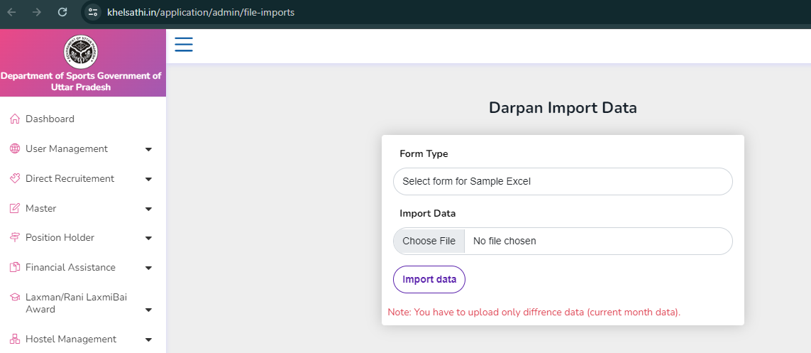

Note: Admin Login is required for this link to work.

Step 11: Select Form Type which is nothing but Scheme Type. Post your click you will be able to download a sample file to be uploaded

Step 12: Upload the relevant file.

Step 13: Click on Import Data. This is the Final step for the Darpan data upload procedure

Points to remember:
- Darpan count needs to be uploaded on the first day of a month otherwise marks will get deducted.
- Darpan's detailed data can be uploaded by the 5th of a month
- Remember to update the applicant's mobile number if available because it may lead to point deductions.
- If you don’t have any data for an application, then also, you have to upload its data with a count of 0,0,0,0 in the Darpan Count Data link.
- If the data for a scheme is 0 for a month, no need to upload a file in the Darpan Detailed Data link.
- Data for Prize Money, Financial Assistance/Monthly Pension, and Direct Recruitment is published every month. While data for the Laxamn/Rani Laxmi Award is published annually.
- You may follow the below link where you will be able to see the uploaded data in our portal.
Link: https://khelsathi.in/application/darpan

